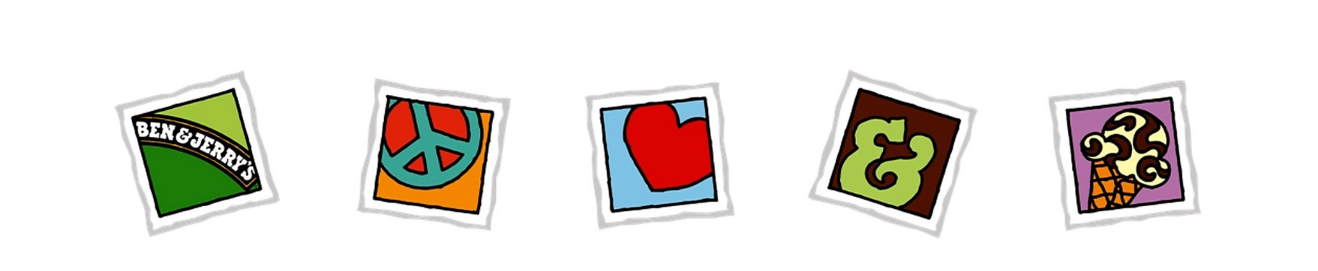

**Ben & Jerry’s Catering FAQ’s**

*What kind of events do you cater?*

We cater events small and large, from birthday parties, anniversaries, bar mitzvahs, bat miztvahs, tenant appreciation, employee appreciation events, conferences, business meetings, office parties and any other celebration. Our professional staff has uniforms for every type of event – tie dye, business casual, formal and a variety of other fun uniforms!

*Can you do an outdoor event?*

Absolutely! We’re flexible about the kinds of settings we work in.

*Is there a minimum number of people for a catering event?*

We can cater any size event. We do have a minimum catering charge of $350.00.

*What comes with the catering?*

In addition to the super premium ice cream, frozen yogurt and toppings, we bring everything else needed for your event, including the equipment, cups, spoons and napkins.

*What do I need to provide for a catering event?*

Sometimes we’ll need access to electricity. Otherwise we have everything else that we need.

*How long will you serve?*

We’ll arrive 30 minutes prior to the agreed upon serving time and serve for one hour, or longer if needed.

*How many flavors will you bring?*

Up to four flavors are recommended to keep things simple and so as not to run out of a flavor. Complimentary tasting sessions included prior to your event.

*What happens to the leftover ice cream?*

We always bring much more ice cream than we’ll actually serve so that your guests won’t be disappointed by a flavor running out. Any extra ice cream is brought back with us.

Please contact our catering expert at 603-455-1884 or email at JayneLCohen@gmail.com with any other questions.